Dis-Mex-Chupicuaro-Figurine-500-100 BCE

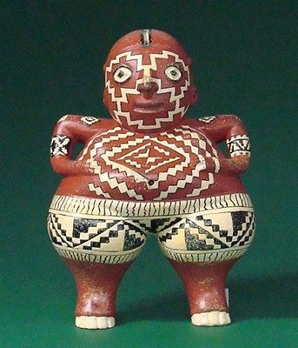 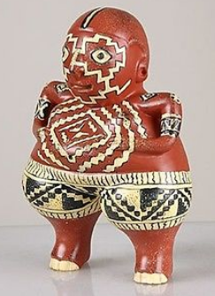 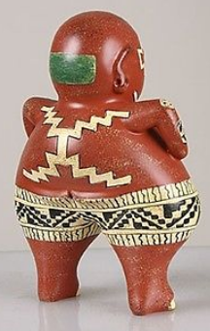

**Formal Label: Mexico,** Chupicuaro Female Figurine-500-100 BCE

**Accession Number:**

**LC Classification:** N6504

**Date or Time Horizon:** 500-100 BCE

**Geographical Area:** archaeological site in the Lerma River Basin in the State of Guanajuato, Mexico

**Cultural Affiliation:** Chupicuaro

**Medium:** Original: ceramic with painted geometric designs in three colors, red ochre, limonite and charcoal. Reproduction: resin with hand-painted color details to resemble the original terracotta painting.

**Dimensions:   
Weight:**

**Provenance: Reproduction**

**Condition: New**

**Discussion:**

The oldest culture in the west coast of Mexico is the Chupicuaro (500-100 BCE), named after the archaeological site in the Lerma River Basin in the State of Guanajuato, Mexico. The name Chupícuaro derives from the Purépecha language *chupicua,* (*Ipomea tricolor* = Morning Glory), the biochemical content of the seeds of which have medically and psychoactive compounds, mainly alkaloids, potent entheogens (‘creates god within.’) Therefore, the Chupicuaro culture is identified with the potent entheogens that these *chupicua* seeds produced. Also, seeds of *chupicua* were used by Aztecs (Aztec=*tlitliltzin*) and Zapotecs in shamanistic and priestly divination rituals. “As with the sacred mushrooms, the use of hallucinogenic Morning Glories, so significant in the life of pre-Hispanic Mexico, hid in the hinterlands until the present century” (Mitra 2009). The ceramic tradition of the Chupicuaro is one of the best known of Central America. Most of the famous three-colored pottery is found in graves and consists of geometrically decorated vases and vessels and animal and human figurines that are painted with stunning geometric designs may represent the hallucinogenic experiences with the *chupicua* alkaloids experienced by the deceased. This is especially suggestive in the designs on the present female figurine. The zigzags on the face and the breast suggest the entheogenic effect of the alkaloid, while the “zizag x” motif extending from the spine to the upper and lower limbs on the back suggest a stimulating effect of the alkaloid of the *chupicua* seeds.

Little was known about the history of the Chupicuaro site until 1946, when the first rescue excavations due to a dam construction effort uncovered pottery, ceramic figurines (Findley 1998**;** Frierman 1969**)** like this one and tombs (Weaver 1956). The many skulls and beheaded skeletons (Flores 1992) suggest that these may have been enemies submitted to an *chupicua* horror trip before their deaths as did the Aztecs to their enemy captives (Mitra 2009). Normally, female figurines are usually extremely broad-hipped, probably as a symbol of fertility. As the original hunter-gatherers established their sedentary life-style fertility took on an all-encompassing urgency for the welfare of the community and extended from their maize, bean and squash staples to their herded animals and their people. The original site is currently under water, although there is one outlying site, Ibarrilla in Leon, Guanajuato, excavated and which is suggested as within the Chupicuaro sphere of influence. Further influence afield may even be extended to the American Southwest.

**References:**

# Findley, Sheila Ann. 1998. Not just pretty ladies: an analysis of anthropomorphic clay figurines from the preclassic site of Chupícuaro, Guanajuato, Mexico. M.A. University of California, Los Angeles.

Flores, Dolores. 1992. *Ofrendas funerarias de Chupícuaro, Guanajuato: catálogo de las colecciones arqueológicas del Museo Nacional de Antropología, Instituto Nacional de Antropología e Historia*. México, D. F.: Instituto Nacional de Antropología e Historia.

Frierman, Jay D. 1969. ***The Natalie Wood collection of pre-Columbian ceramics from Chupícuaro, Guanajuato, México : Ethnic Art Galleries, University of California, Los Angeles, 14 October-30 December 1968*.** Los Angeles: University of California, Museum & Laboratories of Ethnic Arts & Technology.

Mitra, Anil. 2009. *Journey to Being.* <http://horizons-2000.org/1.%20World%20and%20Being/realization/being-elements/2010/Journey%20in%20being-detail.html#_Toc395082248>

Weaver, Muriel Porter. 1956. ***Excavations at Chupícuaro, Guanajuato, Mexico*.** Transactions of the American Philosophical Society, new ser., v. 46, pt. 5. Philadelphia, American Philosophical Society.